ReactJS StudentApp Exercise Report
This document describes the steps I followed while completing the ReactJS Student Management Portal exercise. It is written as a simple record of the work completed.

Exercise Instructions
I first read the lab instructions carefully. The task was to create a React application named StudentApp, create three components (Home, About, and Contact), and display a welcome message from each component.

Initial Attempt
I initially tried to create the project using the command 'npx create-react-app StudentApp'. The command failed because current npm versions do not allow uppercase letters in project names.
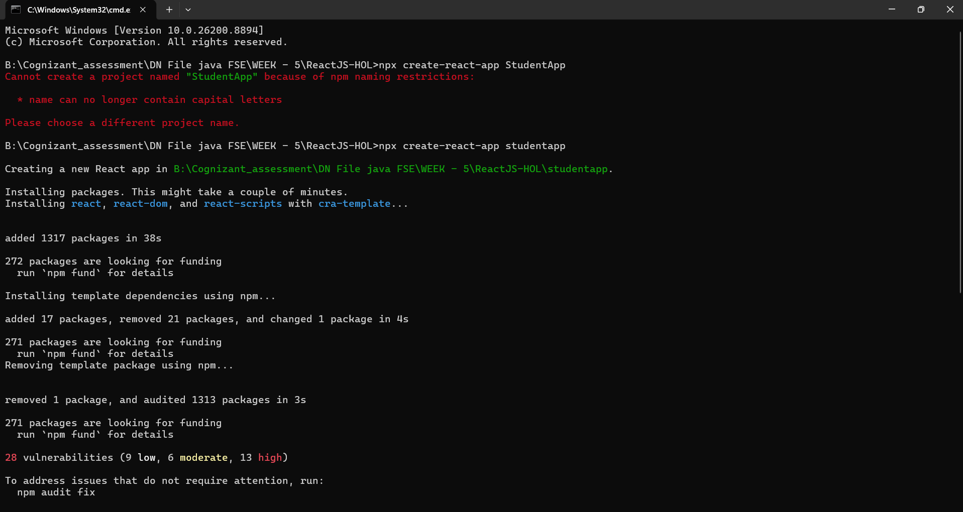

Creating the Project
I created the project successfully using the lowercase name 'studentapp'. The installation completed successfully and npm displayed the available commands for the project.
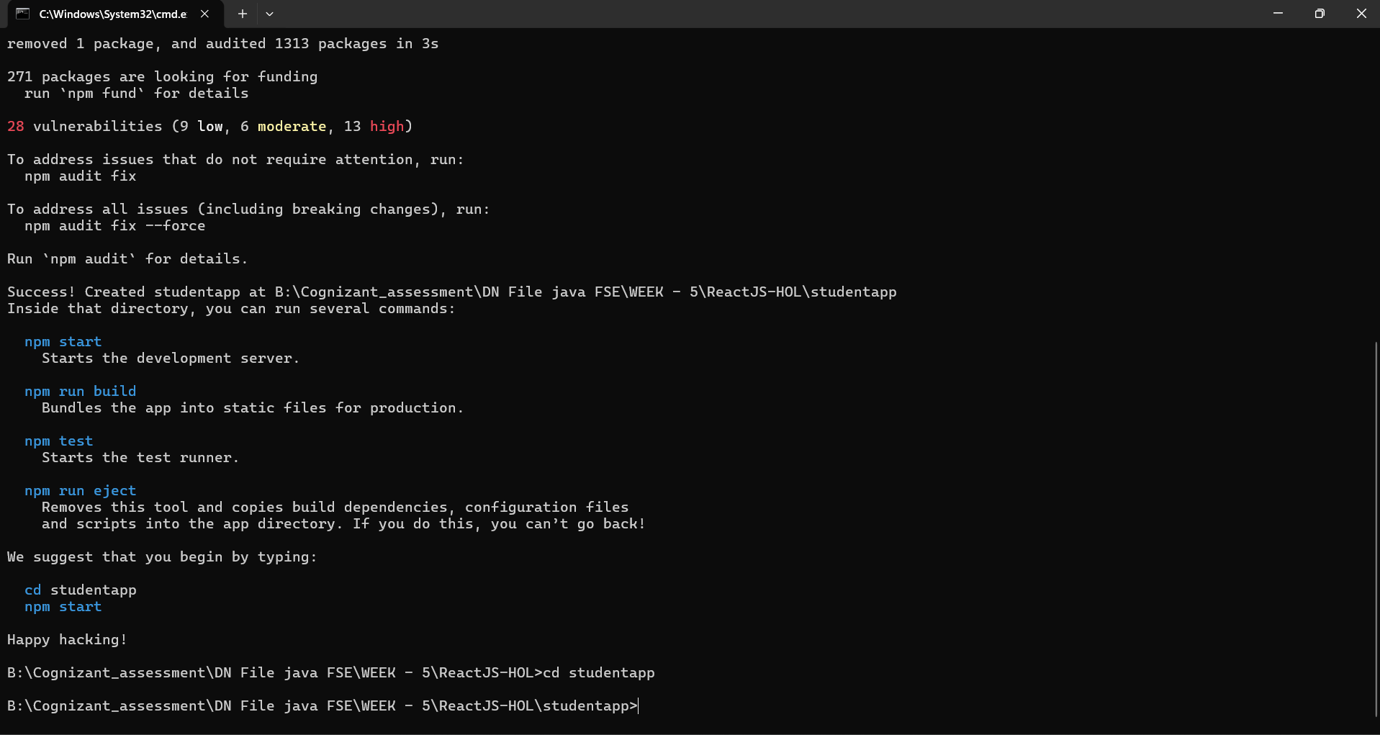

Project Development
After creating the project, I opened it in Visual Studio Code. Inside the src folder I created a Components folder and added Home.js, About.js, and Contact.js. Then I updated App.js to render all three components and started the development server using 'npm start'.
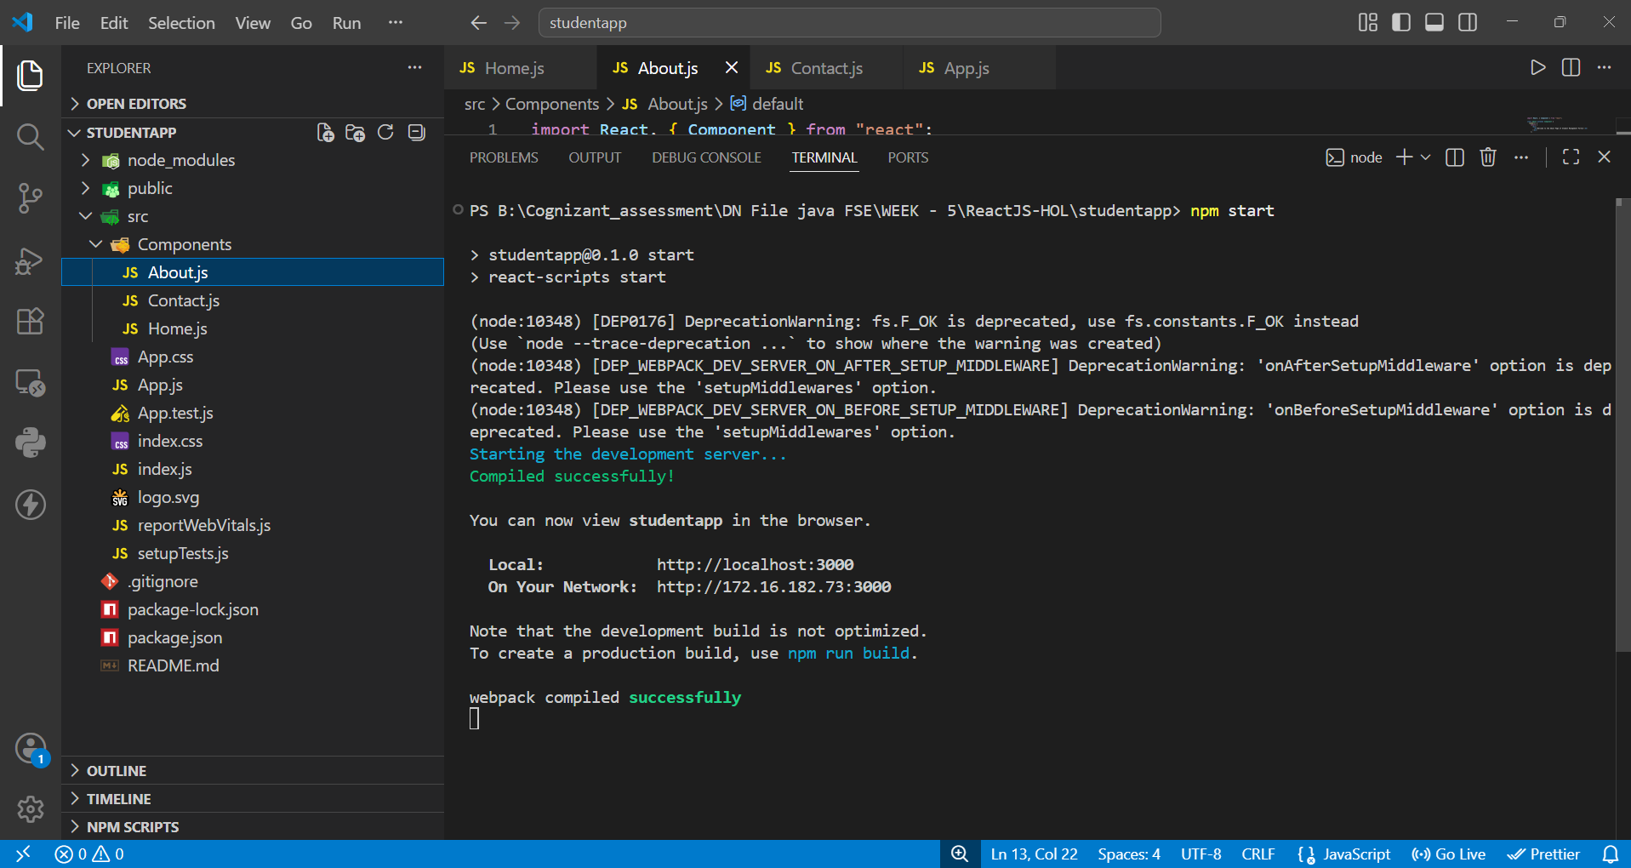

Final Output
Finally, I opened the application in the browser at http://localhost:3000. The page displayed the messages from the Home, About, and Contact components, confirming that the application was working correctly.
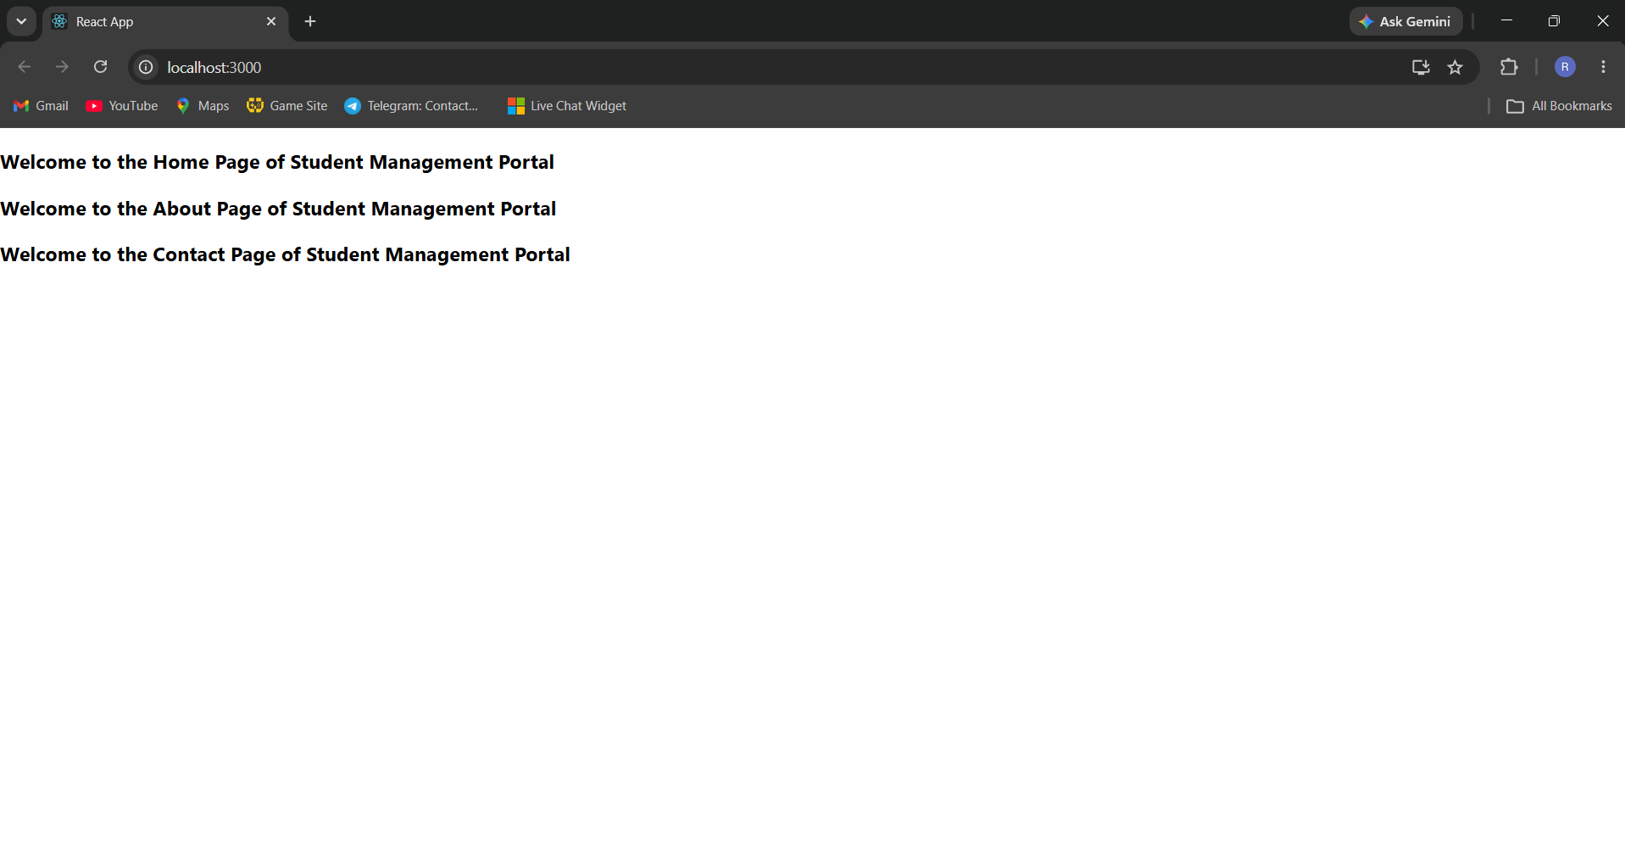

Conclusion
The exercise was completed successfully. Although the original instructions used the project name 'StudentApp', the latest npm naming rules required using 'studentapp' instead. After creating the three components and importing them into App.js, the application compiled successfully and produced the expected output in the browser.

